Cover Letter

November 1st, 2018

Greetings Dr. Roysam,

We wanted to thank you again for approving our Makerspace and senior design project, Knuckles, the assistive robotic arm to be exhibited at the 2019 ECEDHA Conference in Tucson, Arizona.

I’m glad to report that we just finished the 3D-printing phase and ordered all of the parts for building the robot. We are planning on finishing assembling the arm this week to display it at the IEEE Makers’ Showcase. The robot should be able to be controlled with a physical controller for the event and controlled with ROS within the following weeks. We are currently almost done with the 3D mapping and object detection simulations.

We are still discussing some current needs such as the Intel Voice Enabling Development Kit and a PC. But as they are required at later dates, we are going to seek company sponsorship to lower the overall cost to the department.

Thank you for your continued support of our research. If you have any questions or concerns, feel free to contact us.

Sincerely,

Andrew Blanchard

Matthew van Zuilekom

Rym Benchaabane

Paola Hernandez

# 

# Knuckles, an Assistive Robotic Arm Sponsored by Makerspace

# Fall 2018

# ADDIE Progress (I) Report

# Paola Hernandez

# 

# Team members:

# Andrew Blanchard, Matthew van Zuilekom, Rym Benchaabane

# 

**Purpose**

Knuckles is an assistive robotic arm that will hand the user requested objects and tools through voice command. It will serve as a convenient assistant that will increase the user’s productivity and decrease the risk of dexterity incidents. Figure 1 represents Knuckle’s ability to respond to voice commands and hand the requested object to the user.

**Overview Diagram and Background**

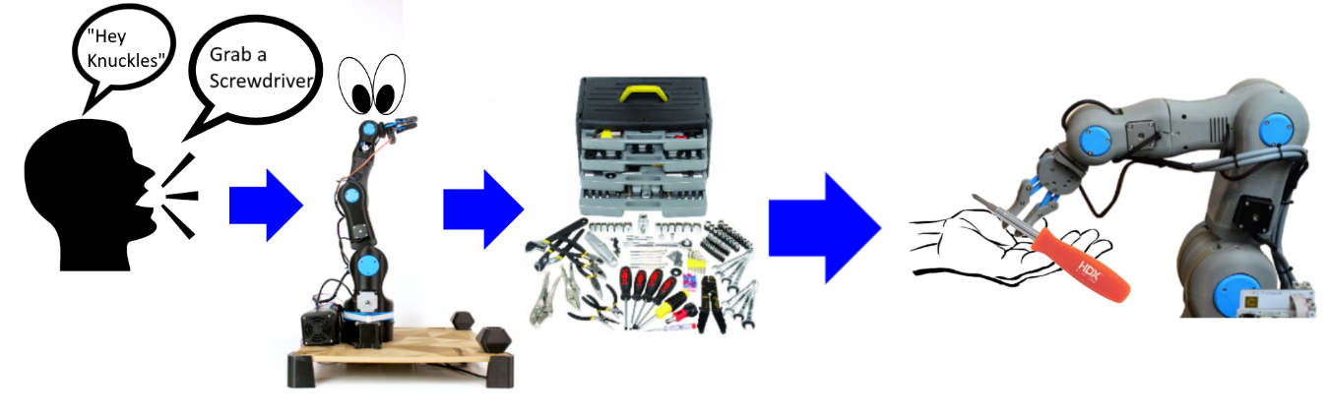

**Figure 1. Overview diagram of Knuckles functionalities**

**Deliverables**

During the Fall semester, our team will provide the hardware part of the project, which will be the physical robotic arm and gripper prototype with additional hardware (Intel RealSense camera, omnidirectional mic, tactile pads). The user will be able to use a developed simulation on the computer to manually control the robot through text commands. Simulation will be executed using Rviz, and text commands, object recognition, manual control of arm and gripper will be planned and completed at the end of the semester.

At the end of the Spring semester, our team will provide the software portion of Knuckles, which will include the object detection and voice recognition portion of the project. With the additional help of the software packages, the user will be able to give voice commands to receive requested objects from Knuckles.

**Design Consideration** 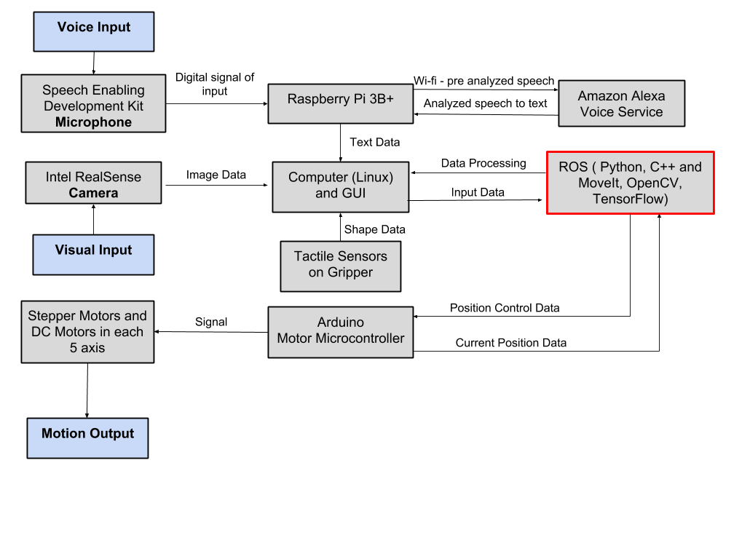

**Figure 2. Design diagram and interactions between parts of the project**

Figure 2 represents the interactions between the hardware and software portions of our project. We are currently working on the “brain” of our project, ROS and the computer technicals. We are currently learning how to retrieve point clouds from the Intel RealSense camera to the computer to process it through ROS (for the 3D mapping portion of the project). We are almost done with object detection simulation and the 3D mapping using the camera. We are done 3D printing parts and have bought the fasteners required to assemble the robot.

The mechanical properties of Knuckles are divided into two components, the arm and the gripper. The arm’s 5-axis movement and mechanics will be developed using ROS on Linux Ubuntu 16.04 LTS. We are connecting the arm’s joints with a total of 6 stepper motors (2 for the base). These motors will be processed by ROS and controlled by Arduino. Programming the ability to move autonomously allows the robot to decide how to move without external input beyond voice commands or manual input on ROS. The gripper is a three-finger design; each finger will have a set of tactile sensors to give the robot feedback on the pressure applied to the object it is attempting to grasp. The gripper will be controlled by a DC motor with an H-bridge. The gripper can therefore respond accordingly and autonomously adjust its grip with sensors. Once functioning in conjunction with the software components, it will be able to calculate and complete the best path to the item and its return path to the user. The robotic arm and the gripper will be 3D printed using an AutoCAD design. The design is inspired by the open source robotic arm BCN3D MOVEO (3D printed), with the gripper designed from an IEEE research paper.

For this project, we are programming in Python 3.5 and C programming. The two main software applications are visual and voice recognition.

The visual processing for Knuckles, including mapping and object recognition will be handled using OpenCV, RViz, and TensorFlow. Knuckles will utilize the Intel RealSense Depth Camera D435 using the mentioned software packages in ROS. OpenCV analyzes the video feed to detect, identify, and log the location of objects as the room is mapped. The recognition features will be executed through TensorFlow. RViz is our 3D visualization application for ROS that will work with the Intel Camera. These libraries will allow us to access and process images, while training with TensorFlow and improving the visual recognition. The user will activate Knuckles with a voice command which will begin the mapping of its surroundings and the execution of the command.

The robot will be able to receive voice commands to perform actions such as handing objects including phones, pencils, etc. The microphone will be incorporated with an Intel Speech Enabling Developer Kit. This add-on module is designed to fit the Raspberry Pi3 board. The Raspberry Pi3+ sends the audio to the Amazon Alexa Voice Service and receives the text request to be processed using a listening script connected to ROS. The command will be translated into the object data detected from the map created via RViz. The robot’s arm motors will move and execute the motion command. A voice command will be used to “wake-up” Knuckles from its standby state, which then allows Knuckles to execute commands.

Our main design constraint is the time allotted to develop a gripper that’s capable of grabbing a larger range of objects. The Intel Realsense camera does not process images one foot within the origin point therefore we need to consider Knuckles to be able to move away at least a foot to be able to scan the entire workspace.

**Target Objectives and Goal Analysis**

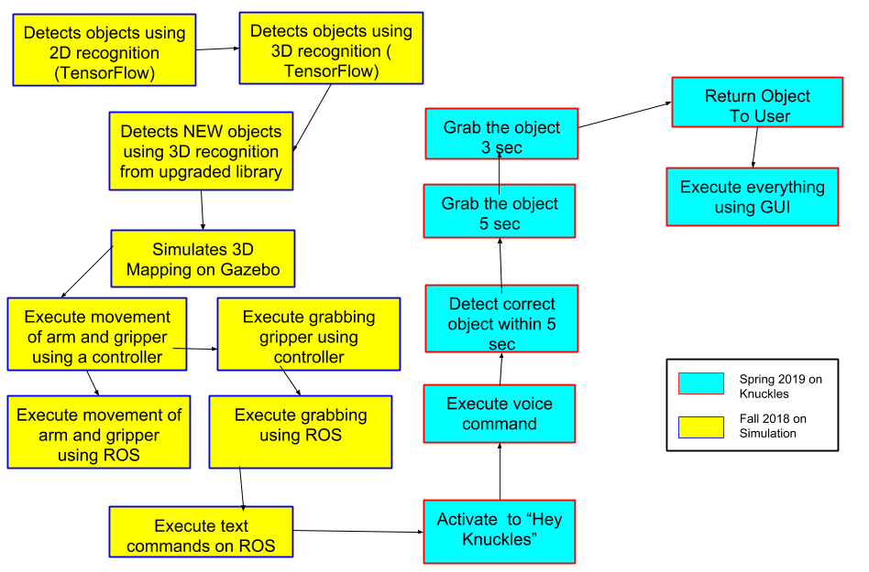

**Figure 3. The testing and goals diagram**

**1. Test the mobility of the robot:** Verify the arm and gripper motion with a controller. This arm uses seven motors: six to control the movement of the arm, and one to control the gripper. The controller will be able to control each of these motors individually by changing the polarity and magnitude of the voltage across each of the motors. This will allow us to confirm the arm is moving correctly and freely, before applying software to it. Two of the six motors used to control the arm will control the same movement at the base of the gripper, so the controller will have to control those two motors at the same time as well.

**2. Test robot connection to ROS:** Request the robot to position itself in straight up, straight out,

and in reaching motions. The test will be successful if these basic movements are shown in both the simulation and the physical arm.

**3. Test object recognition:** Validate the simulation can recognize multiple objects at the same time. We will verify that different frame will surround the different visible objects without naming them yet.

**4. Test the ability of the robot to map the environment:** Compare map data representation to that of the workspace of the robot. Through this we we test the object localization, and recognize the various objects around the arm.

**5. Test the combination of visual recognitions:** Measure and compare the accuracy of object

tags in ROS and in real space. We expect to have the name tags match with the actual object name.

**6. Test the search function:** Use text recognition to have the robot point at objects. This will serve as the initial point where the robot responds to commands. The robot should be able to properly respond to 10 objects.

**7. Test the retrieval function:** Use text recognition to retrieve an object.

**8. Tests the voice recognition:** Compare voice commands to the text in the ROS terminal.

**9. Test the user search function:** Upon voice request, have the robot find the user.

**10. Test the return function:** Have the robot drop the object as close to the user as possible.

**11. Test the gripper with the return:** Have the robot wait until the user is within range and pulls on the object.

**12. Test the timing of the entire process:** Our goal is for the arm to be able to locate the correct object within 5 seconds, and then grab within 3 seconds.

**Schedule**

**Table 1. Team deadlines and milestones**

|  |  |  |  |  |  |
| --- | --- | --- | --- | --- | --- |
| **Date** | **Entire Group** | **Matthew** | **Andrew** | **Rym** | **Paola** |
| **November 2nd** |  | **Print out: final gripper & camera mount**  **Mount gripper & camera on arm** | | **3D object detection** | |
| **November 6th** | ***Ethics assignment due November 6th at 5PM. Group assignment*** |  | ***Buffer*** | ***Presenting in senior design lecture*** |  |
| **November 9th**  **(Makers’ Showcase)** | **Arm is constructed and moveable** | **Find and mount tactile pads** | ***Display built arm at Makers' Showcase*** | **Train object detection can recognize every object will most likely encounter** | |
| **November 16th** | **Tactile pads respond as expected and recognize when an object has been sufficiently grasped** | ***Submit Progress 2 written report by 5PM.*** | **Order voice kit and microphone.** | **Fully functional object detection simulation with RealSense working on RViz. Saves 3D position of the object** | |
| **November 20th (Milestone 2)** | **Simulate the arm design in RViz. Arm has all hardware attachments.**  **Camera works and provides locations**  **Get response from tactile pads.** |  | ***Presenting in senior design*** |  |  |
| **November 21 - 25** | ***Thanksgiving holiday*** | ***Buffer*** | | | |
| **November 27th** | ***Facilitator meetings*** | ***Buffer*** | | | |
| **November 30th** |  | **Physical arm fully follows simulation seen in RViz** | | **Arm properly responds to text commands** | |
| **Date** | **Entire Group** | **Matthew van Zuilekom** | **Andrew Blanchard** | **Rym Benchaabane** | **Paola Hernandez** |
| **December 1 - 12** | ***Final exams, no classes*** | ***Buffer*** | | | |
| **December 7th** |  | **Manual control of robotic arm using a controller** | |  |  |
| **December 14th** | **Microphone can take audio input and convert to text for voice commands** |  |  |  | ***Buffer*** |
| **December 21st** | **Arm can remember path made when controlled and duplicate the motion when given the text/voice command** |  | ***Buffer*** |  |  |
| **January 4th** | **Arm can create 3D map of its environment** |  |  |  |  |
| **January 11th** | **Arm can properly locate requested object (via voice command), pick it up and present requested object to user** | **Redesign base of arm to consolidate and accommodate microphone** | |  |  |
| **January 14th** | ***First day of spring semester*** | **Mount microphone on arm.** | |  |  |
| **January 18th** | **Arm can be given an object, and place that object in an empty spot on the table** |  |  |  |  |
| **January 20th (Milestone 3)** | **Implement 3D mapping using RealSense. Simulate object detection and implement on the physical robot. Robot will be able to locate and pick up objects in its environment** |  |  | **Fully trained object detection can recognize every object will most likely encounter. Responds to voice commands** | |
| **February 15th (Milestone 4)** | **Improved object recognition and user position recognition. Implement voice recognition software to accept voice commands** |  |  |  |  |
| **March 8th**  **(Milestone 6)** | **Implement final voice commands reference library. Robot arm needs to be 100% done!** | **Display arm at IEEE Chili Cook-Off** | | | |
| **March 11th - 17th** | ***Spring Break.* Prep Robot for travel** |  | ***Buffer*** |  |  |
| **March 26th**  **(ECEDHA)** | **Demonstrate arm at ECEDHA Conference** |  | **At Conference** |  |  |
| **April 15th**  **(Milestone 7)** | **Fine tuning based on feedback from IEEE National Conference** |  |  |  |  |

**Budget**

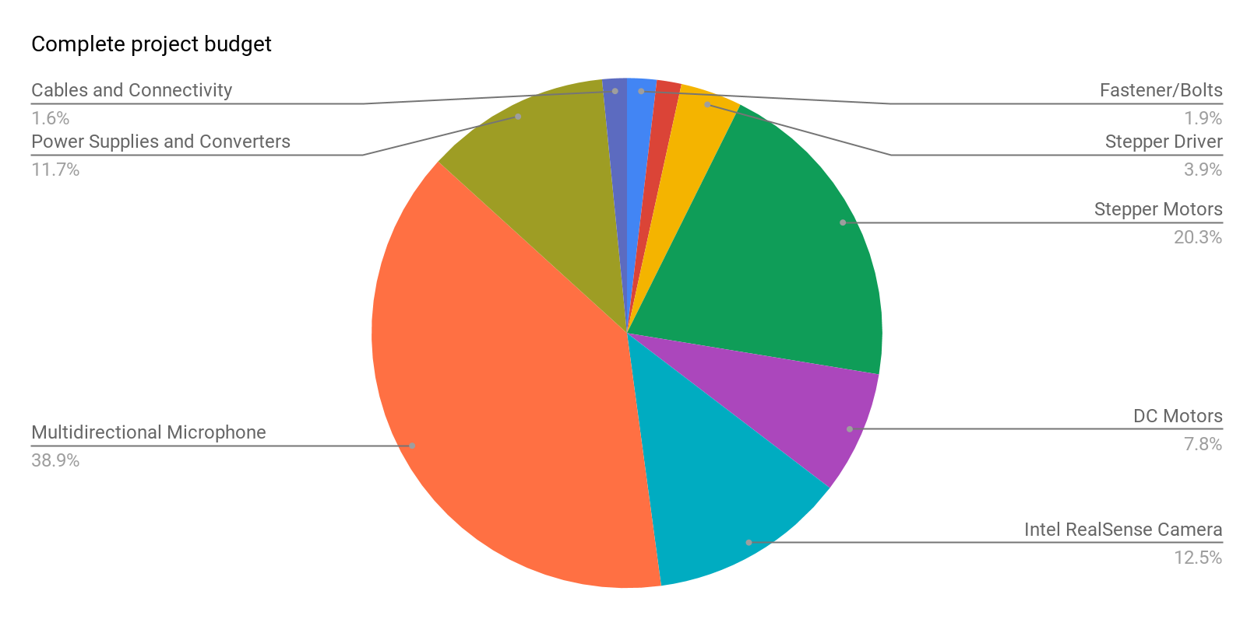

**Figure 4: Graphical representation of budget**

**Project Summary**

By the end of the Fall semester, the physical robot arm will be constructed, and the user can use a simulation in RViz to control the robot through text commands. By the end of the Spring semester, the object detection and voice recognition of the project will be completed, and the user will be able to give voice commands to request objects from Knuckles. We will accomplish our target objective by following a modular test plan, allowing us to develop the hardware and software in tandem. We are on track to complete our project by the end of the Spring semester.